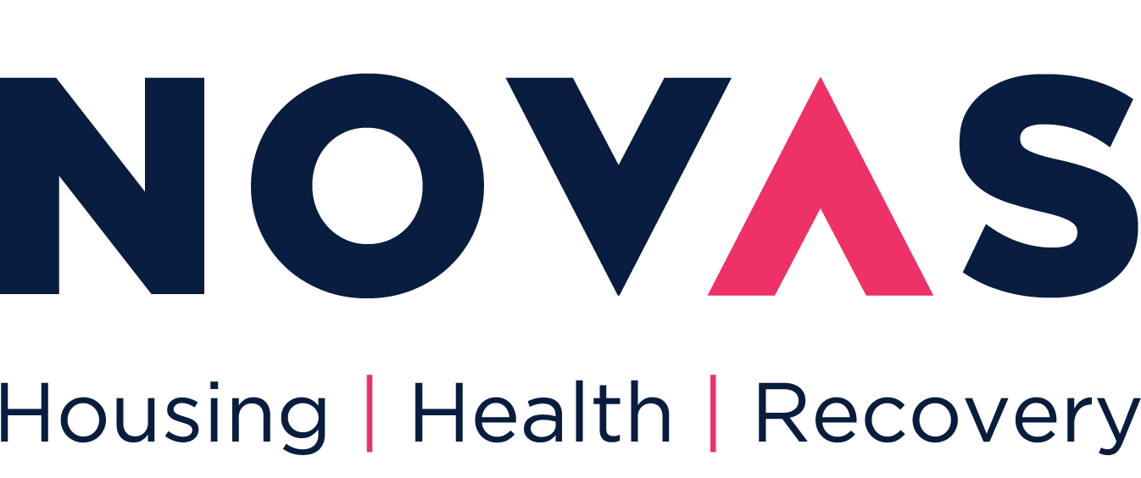
FOR OFFICE USE

Volunteer Ref # _________ Date ________

Volunteer Application Form

Thank you for your interest in volunteering with Novas. The role of volunteers in each of our projects is vital to the work we do and we greatly appreciate your interest in volunteering with us. In so doing you will be contributing to our vision and core goals. All volunteer applications are reviewed with consideration of current volunteer opportunities. The information you provide will be stored in confidence under the provisions of the Data Protection Act. Your completed form will be held securely and confidentially. Only authorized staff will have access to your information. This information will only be used for the purpose of recruiting volunteers.

Personal Details

First Name: | Surname:
Address:

Date of Birth: | E-Mail:
Tel. No. (Home): | Tel No. (Mobile):

If you are involved with us as a volunteer and an emergency arises, whom should we contact?
Name: | Relationship:
Tel. No. (Home): | Tel No. (Mobile):

Please state if you are related to a current or former Committee Member(s) or employee(s) of Novas Initiatives

Name of Person(s):

Relationship(s):

Do you require a work permit? Yes No

Do you have a full clean current driving licence? Yes No

Equal Opportunities

Novas aims to develop innovative projects and initiatives to tackle the structural factors that underlie homelessness, disadvantage and exclusion.

The organisation regards an equality and diversity policy as a matter of justice, and a means of ensuring the provision of good quality services. Novas is committed to promoting equality and diversity in all its activities including its services, recruitment, employment and training.

The organisation will ensure that no person shall be treated less favourably because of homelessness, poverty or as a user of services, or because of race, colour, ethnic or national origin, culture, appearance, gender, sexuality, marital status, disability, age, religious, spiritual or political beliefs or offending history.

Specific justifiable exclusion criteria may apply to certain employment and service areas. These will be legal, open and service-related.

Novas regularly review the effectiveness of the policies, procedures and performance in equality and diversity. Appropriate action plans will be developed and implemented to ensure, continuous improvement in delivering equality and diversity.

Under the Disability Discrimination Act, a disabled person is someone who has a physical or mental impairment, which has a substantial and long-term adverse affect on his/her ability to carry out normal day-to-day activities.

(a) Do you consider yourself to have a disability?

Yes
No
Question Refused

(b) If you consider yourself to have a disability, and you have any needs, which require special provision, please give details:

Criminal Record

Novas promotes equality of opportunity and welcomes applications from diverse candidates. All applicants invited to interview will be asked to disclose all convictions, cautions, reprimands and final warnings. Criminal records will be taken into account for recruitment purposes, only when the conviction is relevant. Having a conviction will not necessarily bar you from volunteering with the organisation. This will depend on the circumstances and background to your offence(s).

Any applicant invited to interview will be asked to disclose any unspent convictions and any offer of volunteering will be subject to a criminal records check.

All criminal records information is treated in the strictest confidence.
Current Occupation/Educational Status

Are you currently:
Employed Profession ________________________________
Student Course ________________________________
Jobseeker Profession ________________________________
Retired Profession ________________________________
Other (Please specify: )_________________________

Your Skills and Interests

1. Have you ever done any voluntary work before? Yes No
If you answered yes, please tell us a little about the experience.

2. Why do you want to volunteer now? What has motivated you to get in touch with us?

3. Do you have any particular skills or qualities that you could use in your voluntary work?

4. Are you applying for a specifically advertised volunteer position? Yes No

If yes, please write the following: Role name:

5. What kind of voluntary work interests you? Tick as many boxes as you wish.
(See ‘Categories of Volunteering’ on Novas website for more information)

Street Outreach (Limerick)
Fundraising
From Our Home to Yours (Dublin)
Driving
Other (please specify: _________________________________________)

6. How long do you intend to volunteer for? __________________________

(note that some opportunities demand a minimum time commitment)

7. Where do you wish to volunteer? ________________

(Limerick, Kerry, Cork, Tipperary, Dublin)

8. How did you find out about volunteering with Novas Initiatives?

Information / Outreach meeting
Novas Website
Leaflet / Poster
Word of Mouth
A Volunteer Centre (please specify _____ )
Media Radio / Television / Newspaper
Social Media (Facebook, Twitter etc)
Other (please specify _______________)

References

1.
Name: | Relationship:
Place of work (if applicable): | Position:
Tel. No. (Home): | Tel No. (Mobile):
Email:

2.
Name: | Relationship:
Place of work (if applicable): | Position:
Tel. No. (Home): | Tel No. (Mobile):
Email:

If you have any queries when completing this application form, please phone 061-370325 or e-mail tracey.mccarthy@novas.ie. Completed applications should also be submitted to this email address. If you would like to find out more about opportunities about where you can volunteer go to www.novas.ie

Is there any additional information you would like to bring to our attention?

I declare that the information I have provided is true. All my actions as a volunteer will reflect the ethos of Novas and I agree that being client centred will be central to my role.

Signed: ___________________________ Date: ___________

For office use only Notes

Volunteer Position ______________________________

Volunteer Interview _____________________________

References Collected ___________________________

Volunteer Start Date ____________________________

